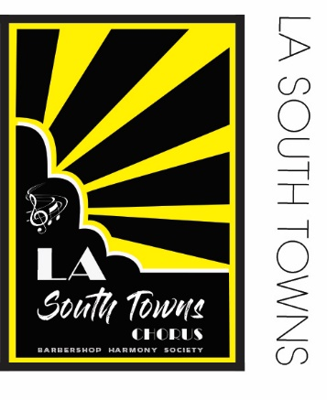
DATE

NAME
ADDRESS

Dear NAME HERE

On behalf of the L.A. South Towns Chorus, thank you for your donation of $ amount.

Your contribution plays a vital role in sustaining our organization! This gift will help to fund new musical arrangements and related activities for our 66-year-old community group. Your ongoing support enables us to continue our mission to share the joy of singing to help make the world a better place!

Please see the “Acknowledgement of Tax-Deductible Donation” form that is enclosed for your use.

With gratitude and in harmony,

_______________________ ________________________
Caroline McLean, Sharon Fair,
Director Board President

L.A. South Towns Chorus
Proud Member of the Barbershop Harmony Society

